# Algorithm for file updates in Python

## Project description

As a security professional it is my duty to protect the access to restricted information. In this project I will update the access of a person who will not need the access to some sensitive information related to the patient’s health.

## Open the file that contains the allow list



The file is opened in read mode

## Read the file contents



The content of file is stored in the ip_addresses file

## Convert the string into a list



The split method converts the string into list

## Iterate through the ip_addresses



Here we are iterating through the ip_addresses

## Remove IP addresses that are on the remove list



.remove() method removes the specified ip address from allow list

## Update the file with the revised list of IP addresses

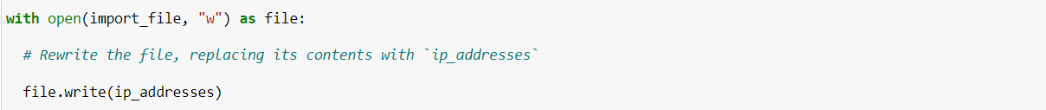

The updated allow list will not contain the blocked ip addresses

## Summary

In this project, we successfully removed the blocked or non required ip addresses from the allow list